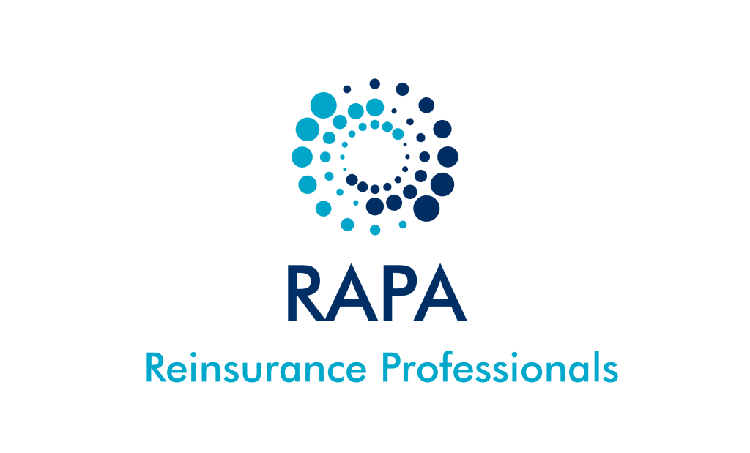

Sponsorship Package
Reinsurance Administration Professionals Association
2018 Conference

Dear Prospective Sponsor:
The Reinsurance Administration Professionals Association (RAPA) will host our annual Conference to be held October 21 - 23, 2018 at the Omni Royal Orleans Hotel in New Orleans, LA.
The annual conference provides the following benefits to attendees:

- Relevant information on industry trends and topics;
- Building business to business connections through multiple networking opportunities;
- Forum for industry knowledge gathering and sharing;
- Communication channel for industry best practices.

RAPA endeavors to offer engaging and relevant topics presented by experts in the industry based on feedback from our conference attendees. In addition to presentations on industry-related topics and networking opportunities, the RAPA Roundtable discussions focus on topics of interest presented by subject matter experts. Attendance at the annual conference has increased steadily over the last several years as more companies discover the benefits RAPA has to offer. Please refer to reinsadmin.org for planned speakers and topics.

Your support and sponsorship of this event helps keep registration costs to a minimum, and allows RAPA to help shape reinsurance industry practices and encourage consistency in the Administration and Operational functions.
Please consider the Sponsorship options attached and select the package that best suits your organization by completing and returning the Sponsorship Confirmation. We respectfully anticipate your favorable response and thank you in advance for your support of RAPA.
We look forward to including your company’s participation in this industry-wide event.
Sincerely,
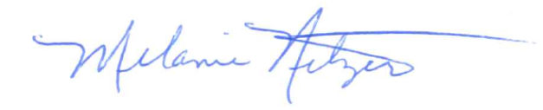
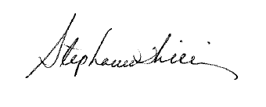

Melanie Netzer
RAPA Planning Committee
Bronze
Level
Silver
Level
Gold
Level
Platinum
Level
Black
Level
Black
$5,000
- Company Logo displayed at one Speaker presentation or one Evening event
- Free registration for four attendees from your company
- Free one-year RAPA Membership for two members
- Advanced copy of Attendee list
- Recognition of Company Sponsorship/Logo on Website
- Acknowledgment in conference materials
Platinum
$3,000
- Company Logo displayed at one Evening event
- Free registration for three attendees from your company
- Free one-year RAPA Membership for one member
- Advanced copy of Attendee list
- Recognition of Company Sponsorship/Logo on Website
- Acknowledgment in conference materials
Gold
$2,500
- Company Logo displayed at Lunch or one Breakfast event
- Free registration for two attendees from your company
- Free one-year RAPA Membership for one member
- Recognition of Company Sponsorship/Logo on Website
- Acknowledgment in conference materials
Silver
$1,500
- Company Logo displayed at the Breaks
- Free registration for one attendee from your company
- Recognition of Company Sponsorship/Logo on Website
- Acknowledgment in conference materials
Bronze
$1,000
- Recognition of Company Sponsorship/Logo on Website
- Acknowledgment in conference materials
Sponsorship Confirmation
RAPA 2018 Conference
October 21 – 23, 2018
Omni Royal Orleans

This confirmation of Sponsorship for the Reinsurance Administration Professionals Association (RAPA) 2018 Conference will become an agreement upon acceptance by the board of directors of RAPA, hereinafter referred to as the Meeting Organizers. Sponsors will receive a confirmation e-mail upon receipt of application and payment. To confirm your sponsorship and method of payment, this agreement must be signed and returned to:
Melanie Netzer
Optimum Re Insurance Company
1345 River Bend Drive, Suite 100
Dallas, TX 75247
Or by email to: Melanie.Netzer@OptimumRe.com

Sponsorship Package
- Black $5,000
- Platinum $3,000
- Gold $2,500
- Silver $1,500
- Bronze $1,000
Method of Payment
- Online payment via credit card at Sponsorship Information - Reinsurance Administration Professional Association
- Check in U.S. funds payable to Reinsurance Administration Professionals Association and sent by mail to:
Garfield McIntyre
Munich American Reassurance Company
55 Perimeter Center East NE, Suite 500
Atlanta, GA 30346
Sponsor Information
Company Name ________________________________________________________
Contact Name _________________________________________________________
Phone __________________________________________________________________
Email __________________________________________________________________
Signature ______________________________________________________________
Date ___________________________________________________________________
Please your send confirmation of sponsorship no later than Friday, August 17, 2018
RAPA greatly appreciates your support and participation!

